|  |  |  |  |  |  |
| --- | --- | --- | --- | --- | --- |
| Date | December 14, 2022 | | | Tester Name | Syed Shahabuddin |
| Environment | Penfax - Test | | | Login used |  |
| Operating System | Windows | Version: | Update: | | |
| Software Used | Edge | Version: | Update: | | |
| Not Applicable | Version: | Update: | | |
| Release version | 22.4.1 | | | | |
| Title | E23.10 | | | | |
| Test Type | Regression | | | | |
| Test Scenario | Payment Confirmation Letter (to FI) | | | | |
|  |  | | | | |
| Expected Results | Verify the batch run successfully and letters generated and saved on member communications  Some payments that should be used during this test to ensure letters printed are:   |  |  | | --- | --- | | **PMT TYPE** | **MEMBER SEARCH REQUIREMENT** | | LIRA | UNDER 50, DEFERRED | | LIRA & RRSP | UNDER 50, DEFERRED | | RPP | UNDER 50, DEFERRED | | LIRA | OVER 50, DEFERRED (PARTIAL) | | RRSP | OVER 50, ABOVE 13K BUT UNDER SMA LIMIT, DEFERRED | | LIRA | OVER 50, DEFERRED, OUT OF COUNTRY FI | | OUTSIDE ANNUITY | OVER 50, DEFERRED | | PRIF | OVER 50, DEFERRED | | LIF | FEDERAL JURISDICTION FUNDS? | | PRIF | VPB MEMBER | | RRSP | VPB MEMBER |   Note: After processing payments, letters aren’t produced for 2 days. (Not just overnight). | | | | |
| Pass/Fail | Pass | | | JIRA# | N/A |

TEST MEMBERS:

|  |  |  |  |  |
| --- | --- | --- | --- | --- |
| SID | LAST NAME | PMT TYPE | MEMBER SEARCH REQUIREMENT | OUTCOME |
| 283370 | TRAAS | LIRA  UNDER 13K | UNDER 50, DEFERRED |  |
| 270400 | TRITHART | LIRA & RRSP  ADDED FEE*  2FI’S | UNDER 50, DEFERRED |  |
| 280661 | TRECKER | RPP | UNDER 50, DEFERRED |  |
| 300254 | TRAN | LIRA | OVER 50, DEFERRED |  |
| 315216 | TREMAINE | PRPP | OVER 50, ABOVE 13K BUT UNDER SMA LIMIT, DEFERRED |  |
| 273300 | TRABALLO | LIRA | OVER 50, DEFERRED, OUT OF COUNTRY FI |  |
| 300162 | TRAFFORD | OUT ANN. | OVER 50, DEFERRED |  |
| 252484 | TRINH | PRIF | OVER 50, DEFERRED |  |
| 262239 | TREPPEL | LIF | FEDERAL JURISDICTION FUNDS?  (STAGED, ADDED END DATE TO EMPLOYMENT PERIOD WITH FINAL JURISDICTION OF FEDERAL) |  |
|  |  | PRIF | VPB MEMBER |  |
|  |  | RRSP | VPB MEMBER |  |

TRAAS

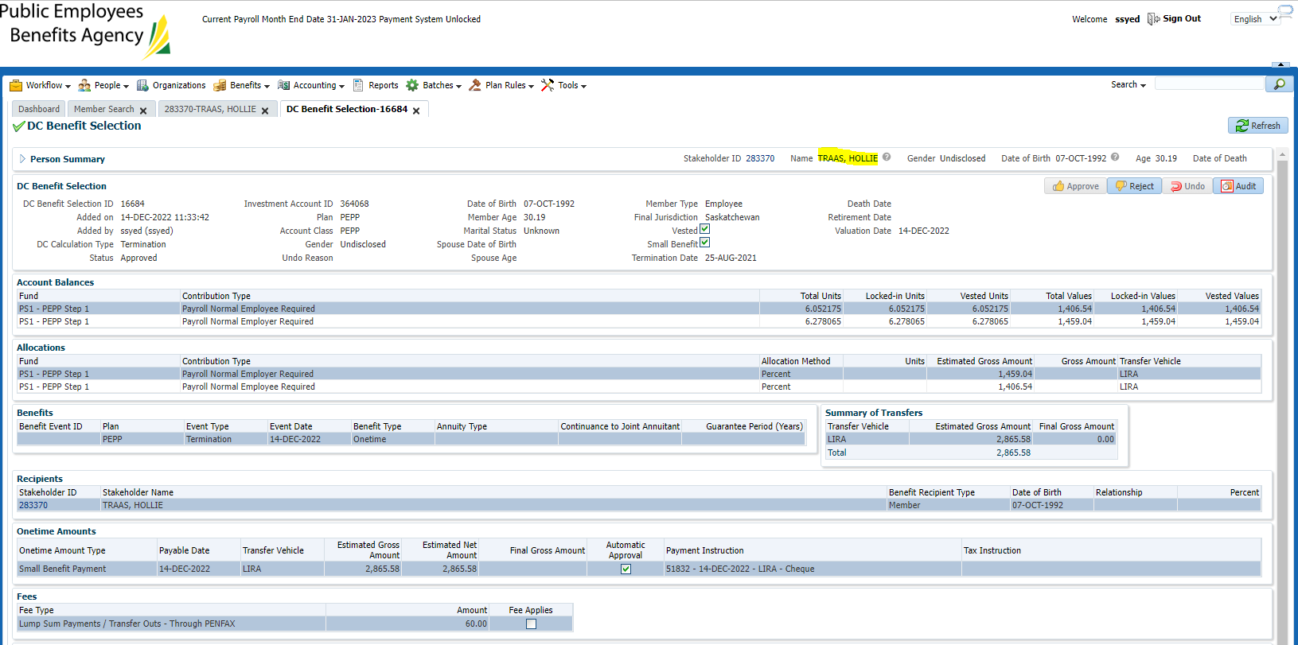

TRITHART

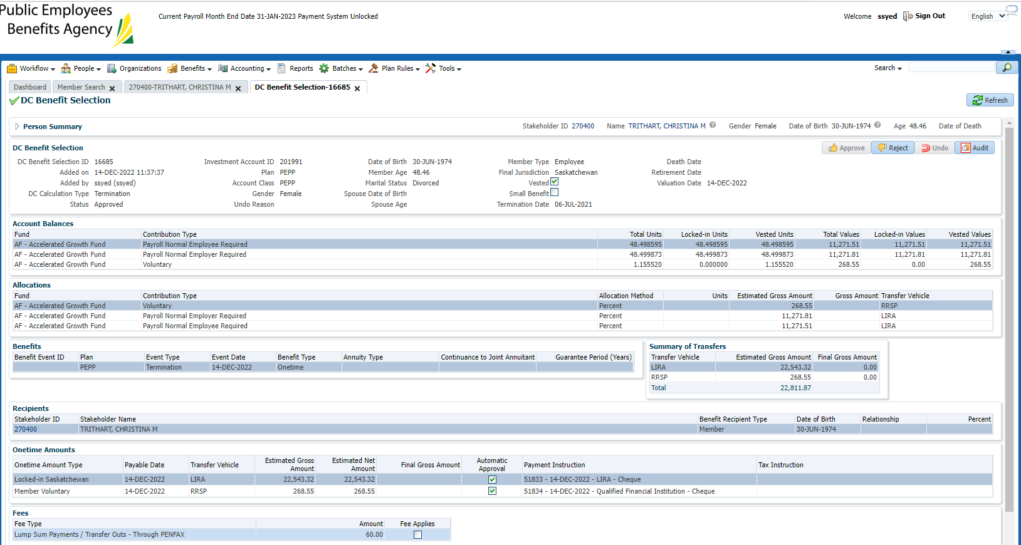

TRECKER

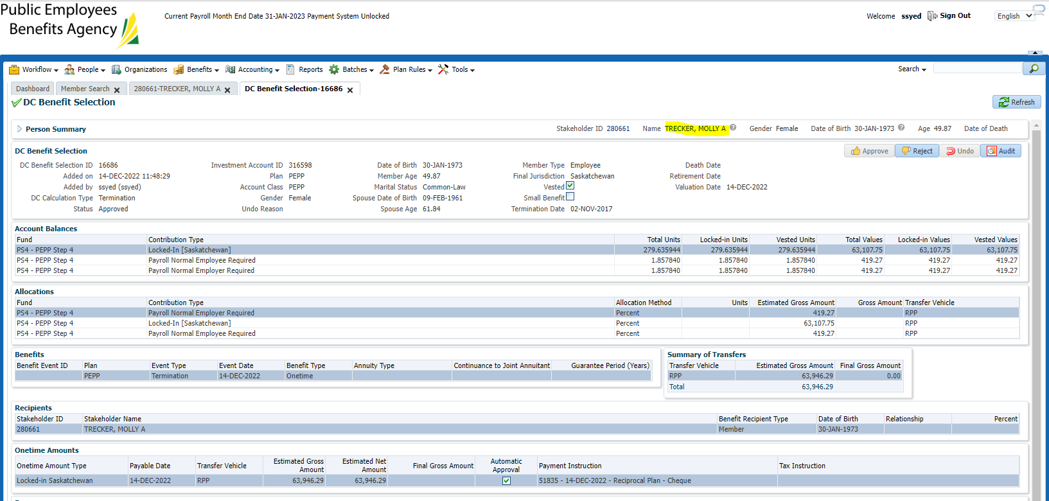

TRAN

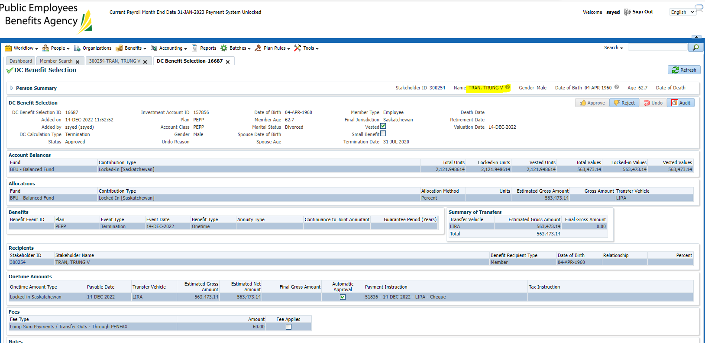

TREMAINE

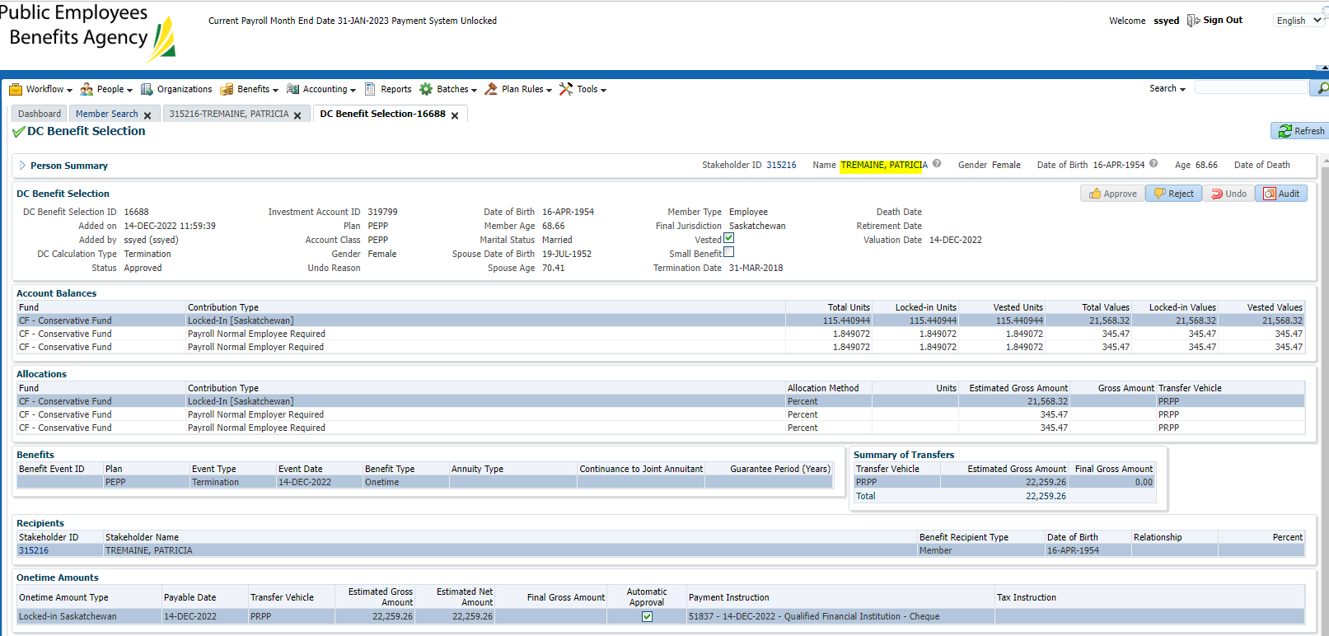

TRABALLO (OUT OF COUNTRY)

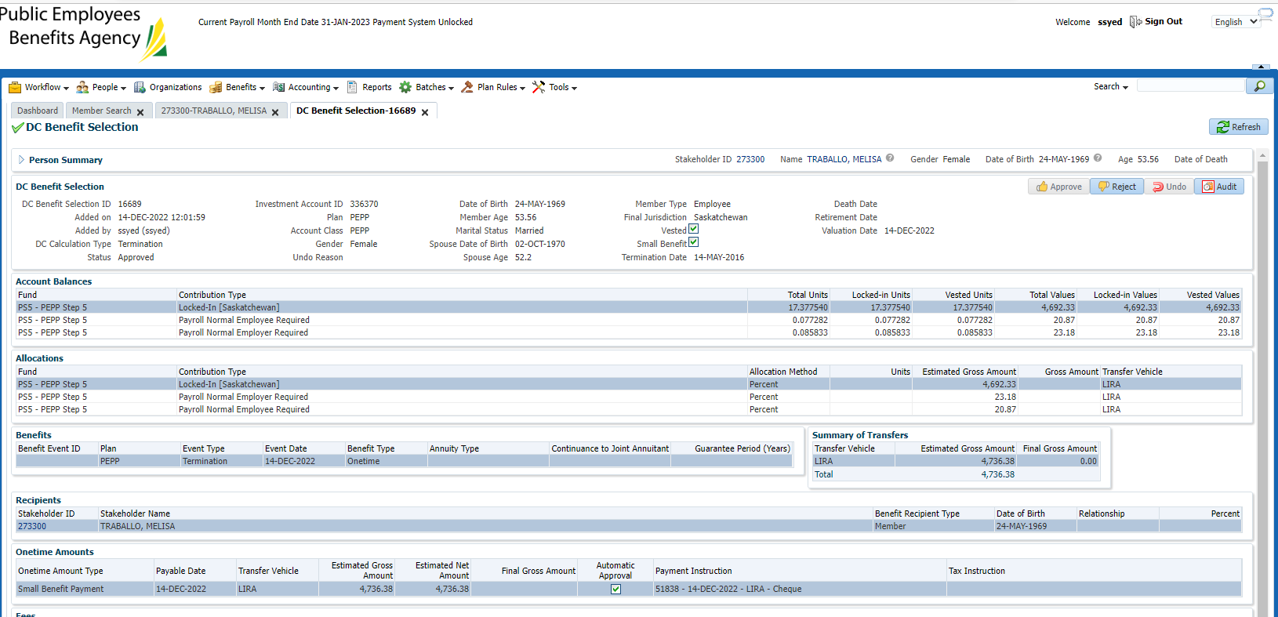

TRAFFORD

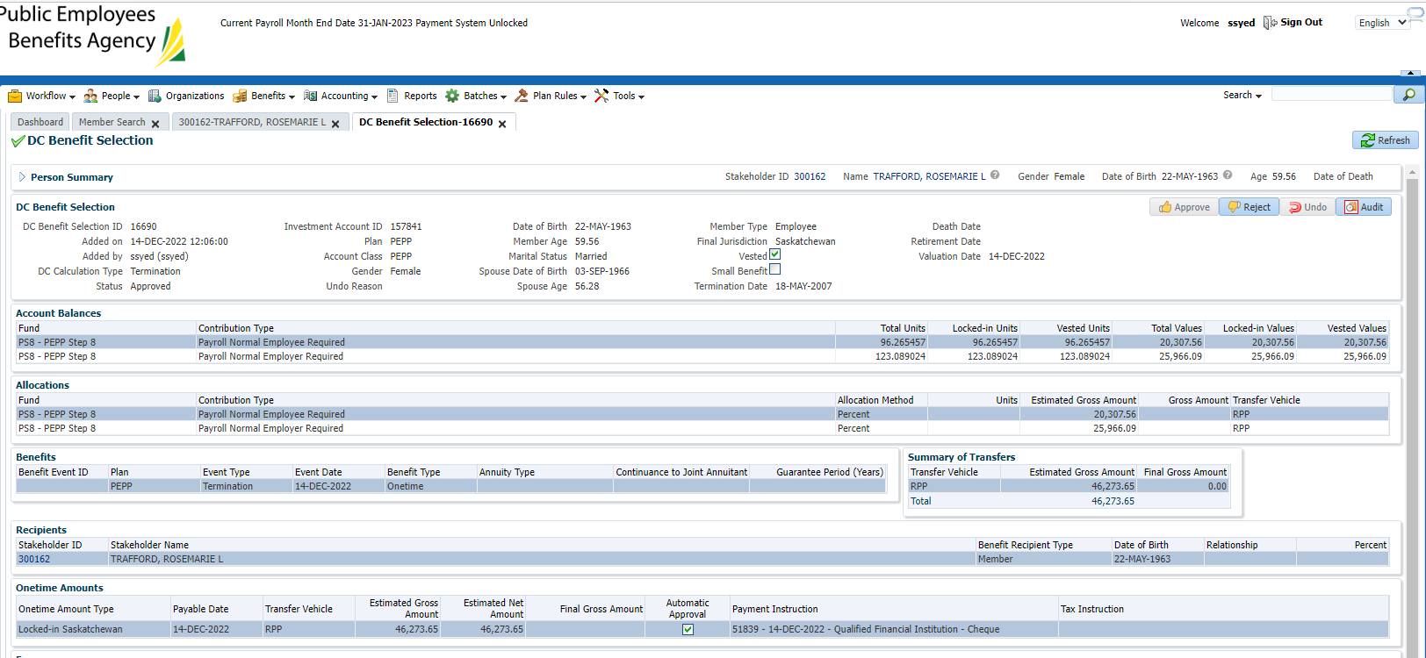

TRINH - PRIF

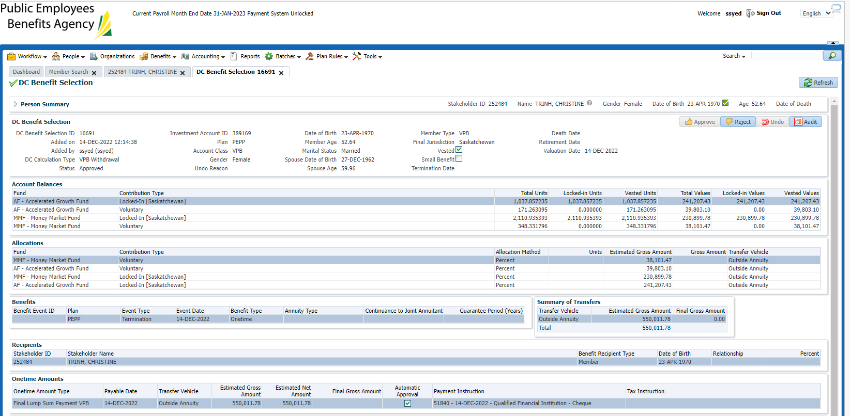

TREPPEL

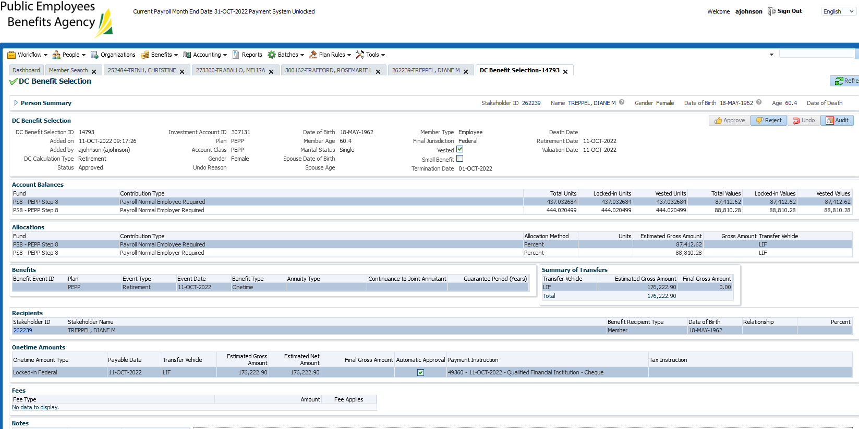

TRUDELLE

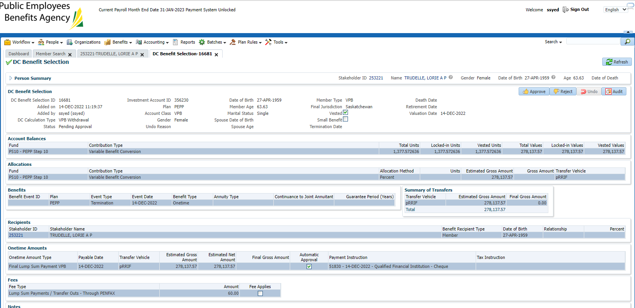

TRIMBLE

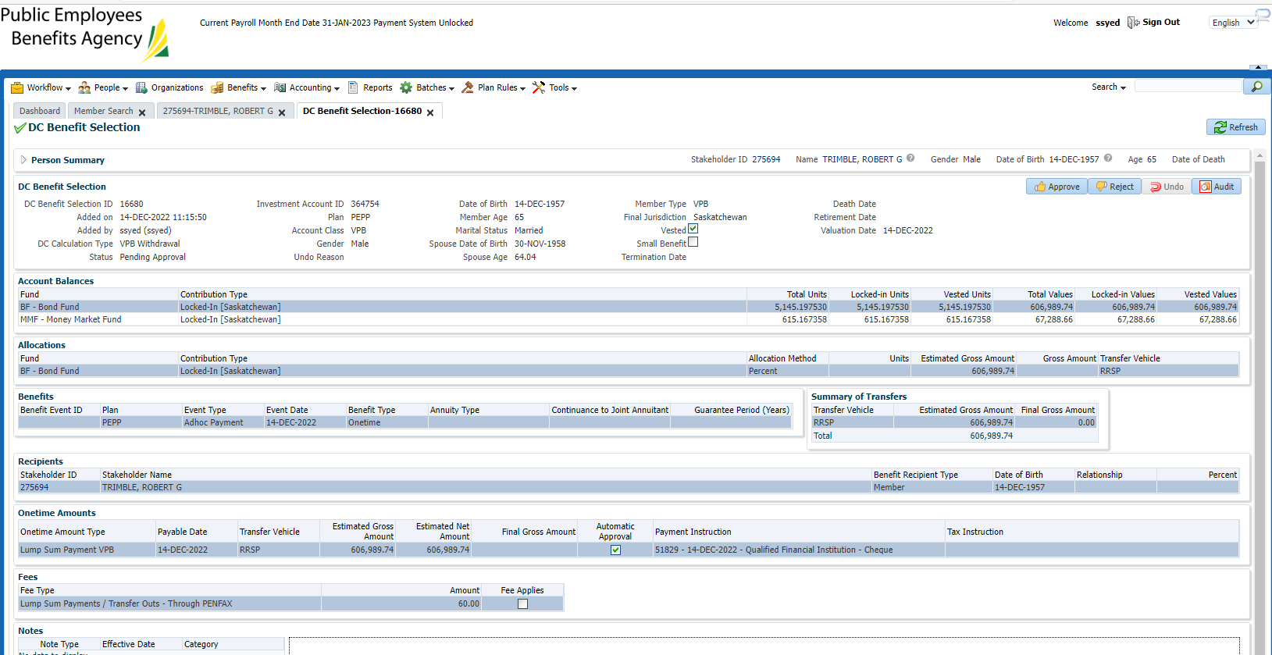

Result: Pass- found letters got generated the next day - confirmed